**How To Use New Mill Log on Grenada Intranet Site**

1. After opening Intranet Site in either Internet Explorer or Google Chrome, Click “Login” on the top-right of the screen. 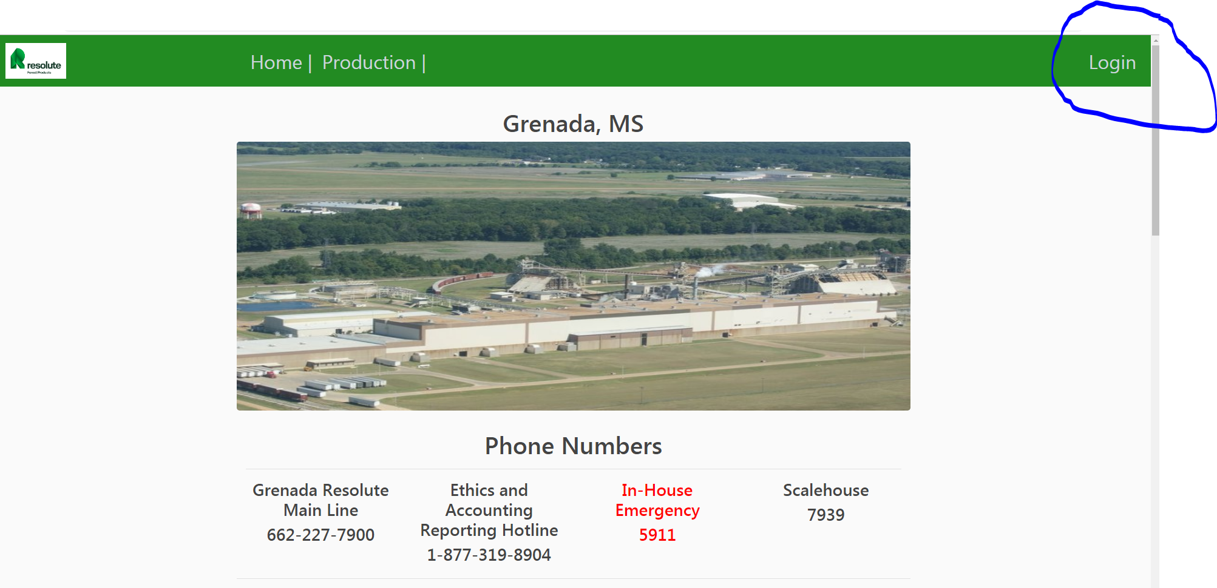
2. Then, type in username and password that was sent to your email or given to you by your IT department and click “Login” at the bottom of the form. 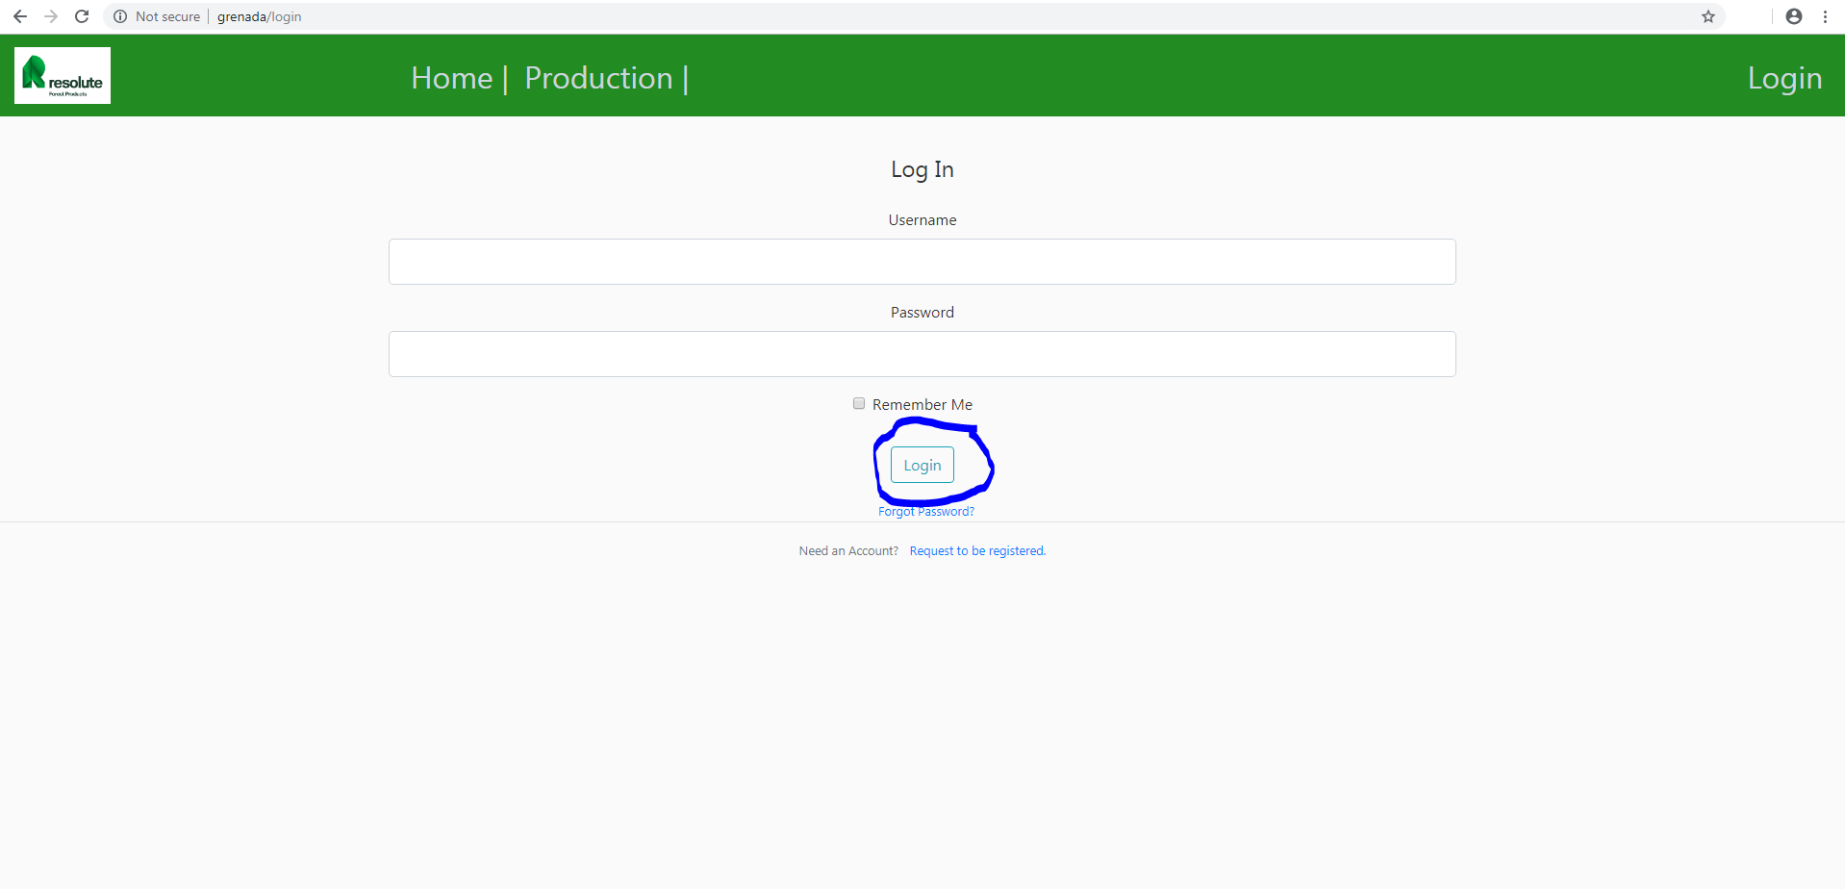
3. Now, click the production tab at the top of the page and click Mill Log. 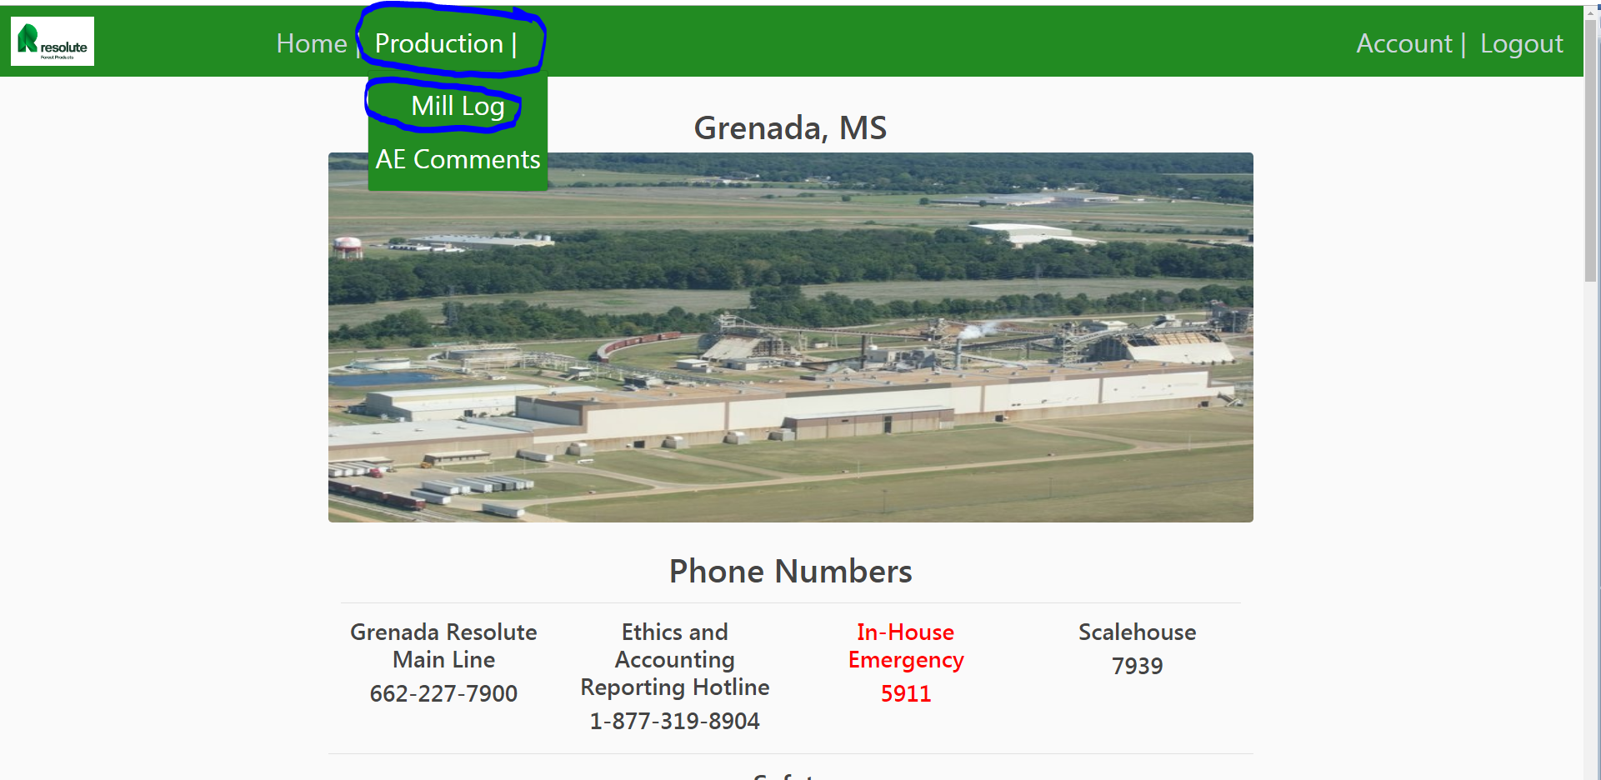
4. From here you can read and search logs, update logs, and create a new log. To create a new log Click the button that says “Create New Log”. 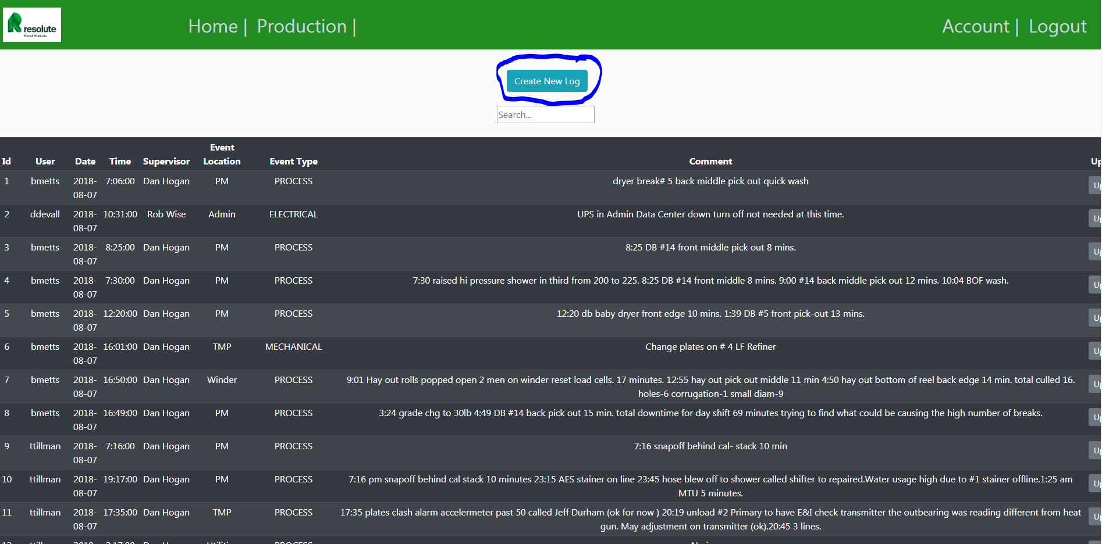
5. Otherwise, to search type something into the search field. It will attempt to match anything found in any column. Try searching by date… Remember that the date should be in the same format that is shown in the date column: YYYY-MM-DD. 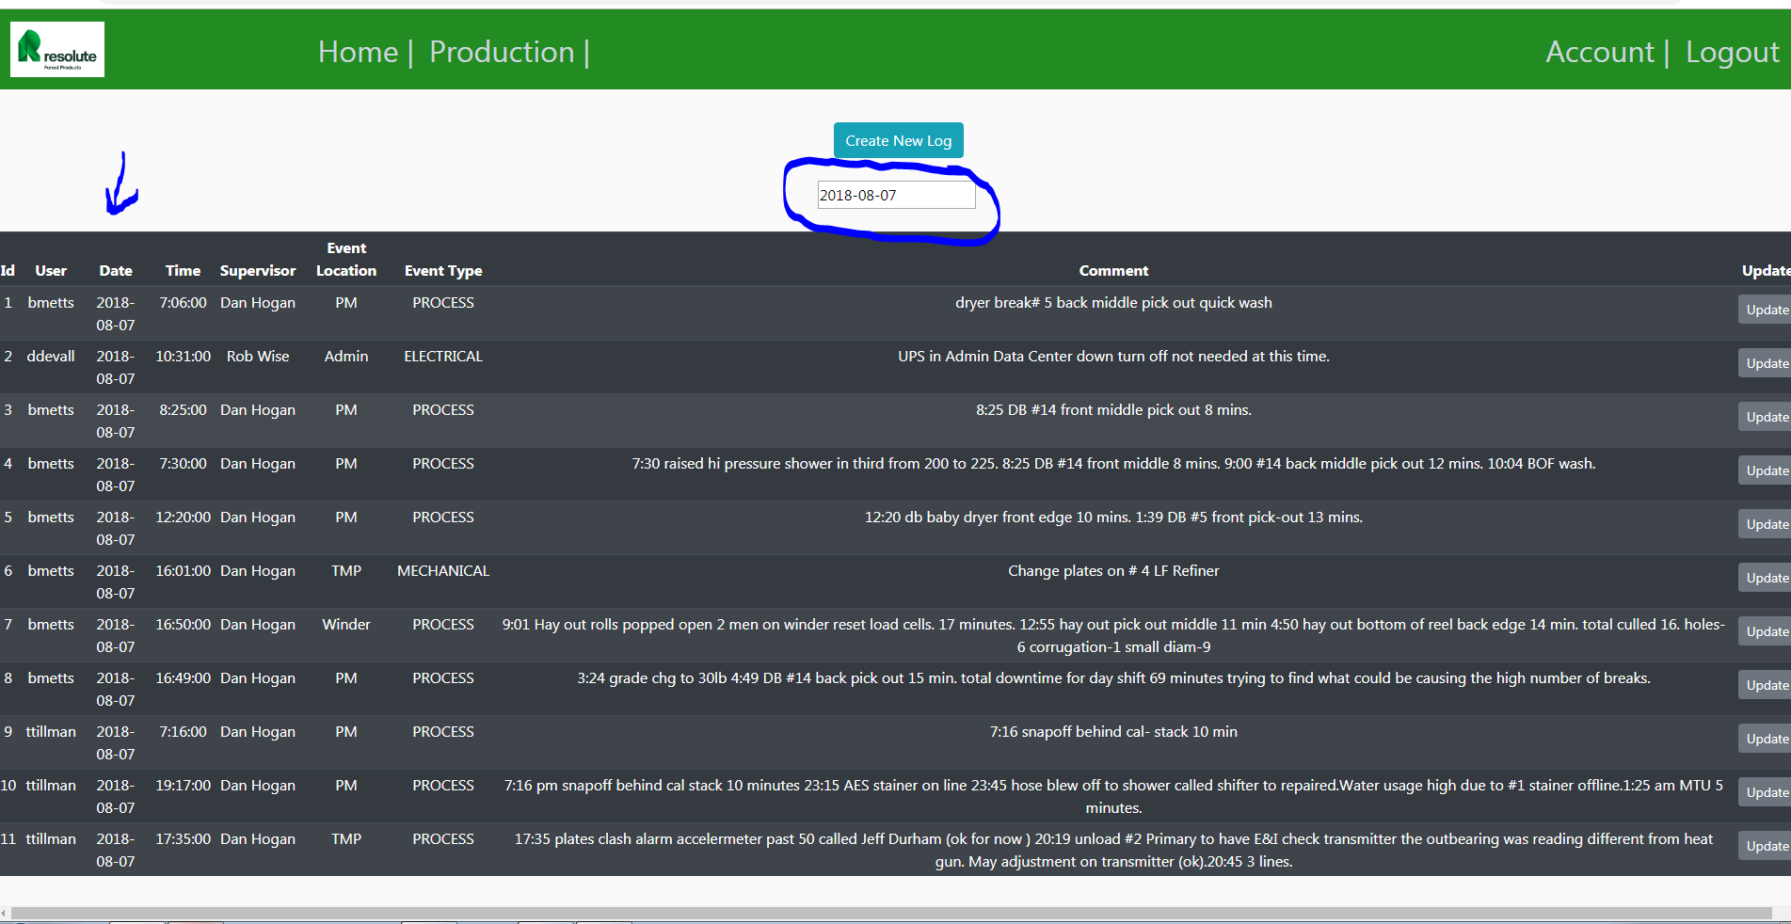
6. Notice the “Update” button on the right. Keep in mind if you update a log, then you become the user of the log. 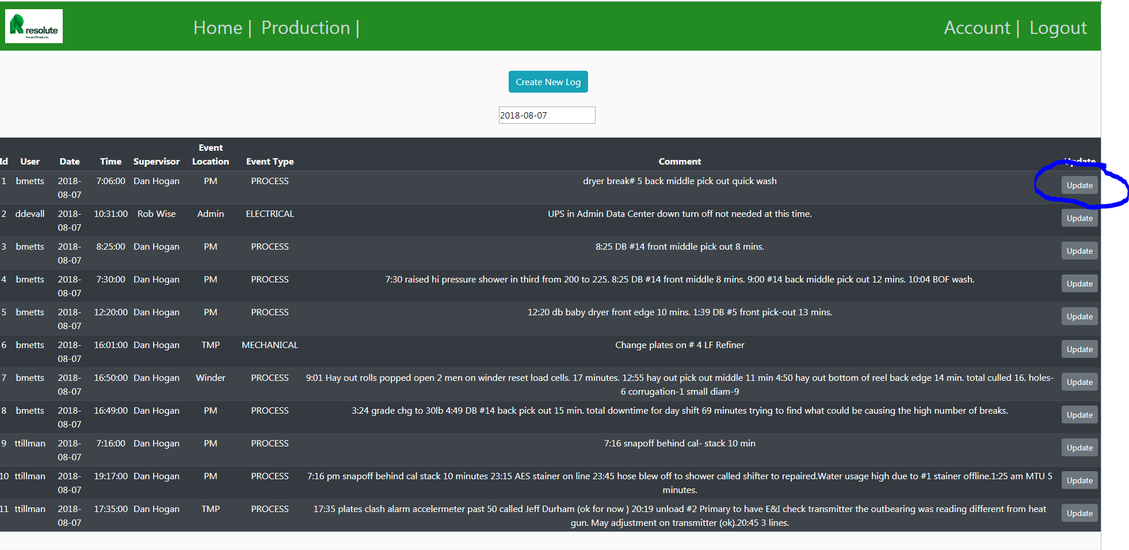
7. Only IT Administrators or high level production users can delete logs. This is to keep logs from being deleted accidentally.
8. Lastly, this is a new application. With this comes technical issues also known as bugs. If you notice anything that you think may not be working correctly. Please, contact your IT Administrator. Sometimes this is an easy fix and sometimes these take time to fix. I hope that you all enjoy the new version of Mill Log, and I hope it makes at least one person’s work a little easier.